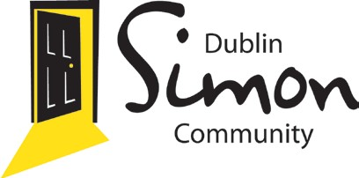

Fundraise for Dublin Simon Community
Dublin Simon Community,
1-2 Cope Street, Dublin 2.
Tel: (01) 671 5551
Fax: (01) 671 5524
Email: fundraising@dubsimon.ie www.dubsimon.ie

Serving Dublin, Kildare, Wicklow.

Thank you for choosing Dublin Simon Community for your proposed Fundraising Event. Please fill out this form and give as much information about your fundraising initiative as possible. It is necessary to have full permission from the Dublin Simon Community fundraising team.

Once we receive your form, we will authorise your proposed fundraising activity in aid of Dublin Simon
Community and you can request an official Letter of Authorisation for the event.

Please fill in the required detail below:

Contact Name (s): Organisation (if applicable): Address:
Contact no: Email:

Seeking Authorisation for :

Name of Proposed Event/Project:
Date of Event/Project: Location: Duration: Description of Event/Project:

Please give a description of how the Event/Project would raise funds for Dublin Simon Community:

Your pledged fundraising income target:

Will 100% of the funds raised be given to Dublin Simon Community or do you intend to pay fees out of the money raised? :

Please outline how you intend to promote this event/project:

Please Specify branded materials needed for event/project

Dublin Simon T-shirts Quantity & Size: Dublin Simon Collection buckets Quantity:
Dublin Simon Sponsorship Cards Quantity:

*Please outline how these branded items chosen will be utilised

Signature of Fundraiser:

Dublin Simon Community Fundraising Procedures

Registering your event with Dublin Simon Community enables you to become an ambassador for the organisation, and therefore you must comply with the Guiding Principals of Fundraising. As an ambassador of Dublin Simon Community you will play an integral part in raising awareness for the work undertaken by the charity.

Please ensure the following:

• You represent Dublin Simon Community with honesty, respect, integrity and accountability.

• Any promotional material, press releases, radio scripts etc. that will mention Dublin Simon Community and its services need to be approved by the Fundraising Team in Dublin Simon Community.

• Keep in contact with the fundraising team in Dublin Simon Community as we can offer advice and support.

• Please request in advance if you would like a representative from Dublin Simon Community to attend your event.

• All collection buckets (if handed over) must be returned to Dublin Simon Community within two weeks of event completion.

• All money fundraised should be returned to Dublin Simon Community as soon as possible by post, online transfer or a visit to the fundraising office in Cope Street.

Regulations:

• Please ensure you have the relevant licence or Garda permit for any public or door to door collections.

• Please have on your person an authorisation letter from the charity during your fundraiser.

