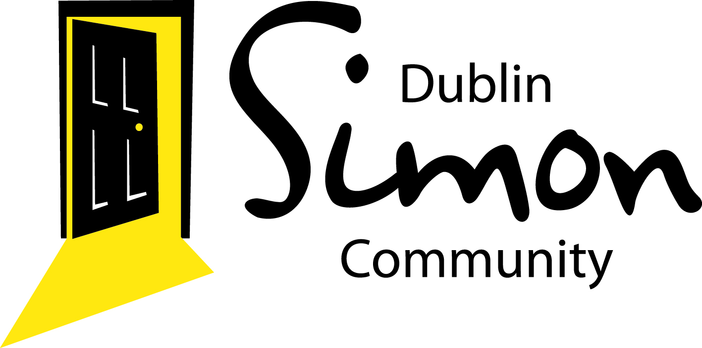

Dublin Simon Community Sure Steps Counselling
Service is seeking applications for placement volunteer Counsellor/Psychotherapists in the Bray/Wicklow Town & Naas Co Kildare areas.

Such positions will offer qualified counsellors/psychotherapists an opportunity to work up their hours towards accreditation. These vacancies are offered on a voluntary basis.

Potential candidates are required to have completed a minimum three year diploma course in Counselling & Psychotherapy, with 100 hours client hours.

If interested in being short listed for interview please forward an up to date CV and cover letter to: derekdempsey@dubsimon.ie.
All positions are subject to Garda clearance. For further information and full role description please contact Derek on 085-889 8022.
Closing date for applications is Friday 15th July 2016

